

solution presentation & training part - 1

Capstone II



|  |  |
| --- | --- |
| Name & Student # | Abirami Mohanasundaram (8886811)  Mounika Boju (8921717)  Parth Babubhai Kalathiya (8884149)  Rechael Vincent Lopes (8928886) |
| Program | INFO8826 – Capstone II |
| Course & Section | 4 |
| Professor Name | Hitarth Smart |
| Due Date | December 1st, 2024 |

Declaration

We, Abirami Mohanasundaram, Mounika Boju, Parth Babubhai Kalathiya, and Rechael Vincent Lopes affirm that the attached work is entirely my own, except where the words or ideas of other writers are specifically acknowledged in accordance with accepted APA citation conventions. This assignment has not been submitted for any other course at Conestoga College or any other global institution. I acknowledge that I have revised, edited, and proofread this paper, and I certify that I am the author of this paper. Any assistance I received in its preparation is fully and properly acknowledged and disclosed. I have also cited any sources from which I used data, ideas, theories, or words, whether quoted directly or paraphrased. I further acknowledge that this paper has been prepared by myself specifically for this course.

Our team has spent approximately 10 hours on this assignment.

Signatures

Mounika Boju

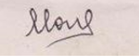

Abirami Mohanasundaram

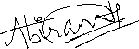

Rechael Vincent Lopes

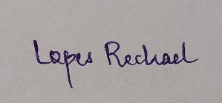

Parth Babubhai Kalathiya

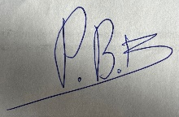

## Academic Abstract

This project will aim to build a rock-solid SharePoint environment for BTS Enterprise that allows for efficient use of processes and enhances colleagues' collaboration. The solution consists of a main site and subsites for Human Resources, Finance, Operations, IT, and Sales & Marketing, each intended to meet the needs of a particular department. Document management, role-based access, and search are the key features of the code. We had UATs done rigorously to confirm the solution will meet all client requirements and is easy to use for all who will use it including their department's requirements so it will be efficient and productive at its best.

Table of Contents

_Toc183974787

Corporate Home Page 4

Department Sub-Site 7

Sub Department Sub-Site 10

Department Process 16

Reporting 20

UAT Presentation 21

Introduction 22

SharePoint Environment Structure 22

Testing Scope 23

UAT Scenarios 24

Feedback Collection 25

Next Steps 25

Conclusion 26

Gantt Chart 27

Team Contributions 27

References 27

Appendix 28

## Corporate Home Page

**Logo Style Guide**

The various platforms representing an organization will need to be absorbed by a logo style guide to abide by consistent branding. It will give detailed instructions on how the logo should be used to maintain integrity and professionalism. Elements such as specific colors, shapes, and typography are usually included in the logo design. Therefore these elements should be in line with the organization’s values (some colors could mean trust and reliability and some shapes could mean innovation and modernity etc.).

For example, the guide also establishes logo variations for various contexts. There could be variations, such as a full-color version optimized if it has a very colorful design, depending on the use of a monochrome one if it’s minimalist, and a transparent or grayscale one to be used when it should be placed as a layer over other images. However, when an issue arises, you want branding to be able to be flexible while staying consistent.

Another equally important part of the style guide is spacing and placement. The logo should always be in clear space, not obstructed, and ensure visual clarity. There should also be guidelines around how something aligns, such as the center for headers or the top center in marketing materials.

Last, the style guide describes when and how the logo can and cannot be used. For instance, it should explain where the logo can be used, like headers for websites and emails, as well as on business cards, and go on to prevent highly specific use cases, such as stretching or changing the color of the logo and adding effects to it. Additionally, the guide should have color codes (HEX, RGB, or CMYK) as well as font details so that everything is standardized, especially when it comes to understanding the guidelines when accessing other branding material.

**Home Page Explanation**

SharePoint home page is the entry point to the SharePoint environment and the page is designed to provide a welcoming and user-friendly experience. The design elements of the page should include a header, a banner, and a footer all aligned with the branding guidelines of the organization. It usually comprises a logo, a navigation menu to access any section, and a search bar for easy access.

As an equally important visual element, the banner serves as a place for presenting the organization’s theme, mission, or current focus. That means we need to set up a home page that has a welcome message that tells the users about the platform while keeping a professional and welcoming tone beneath the banner.

For usability reasons, the home page can include quick links to important subsites like Human Resources, Finance, and IT. Also, there’s an announcements section that you can use to highlight recent updates, upcoming events, or organizational news. That way, they are informed of the key activities happening.

The home page design ends with the footer that contains important contact information, privacy policies, and links to other resources of the organization. Of course, on top of making it beautiful, the home page must be the most intuitive ever for the user: easy to navigate, responsive for mobile users, and classy powerful search for quick access to documents and subsites. Together, all of these make sure that the home page is functional, provides information, and is suitable to the organization's goal.



The homepage of BTS enterprise, which has subsites for the departments in the organization

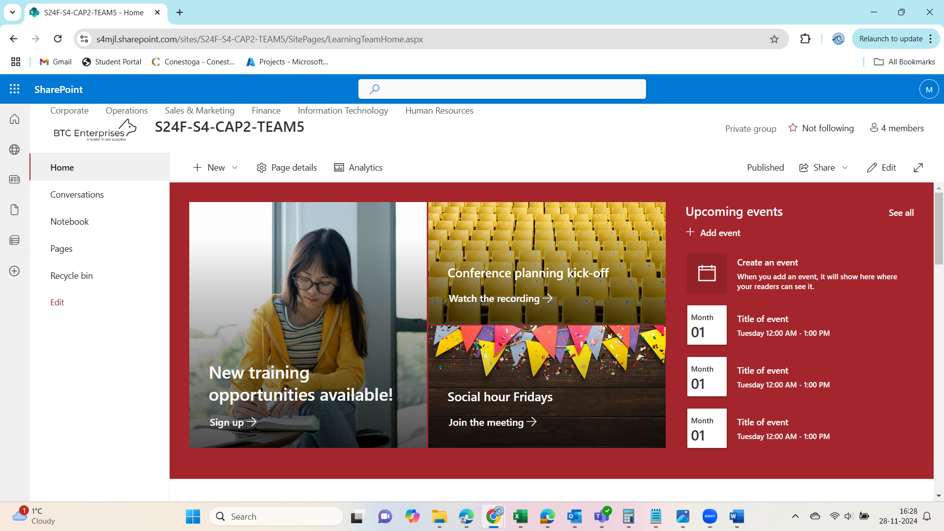

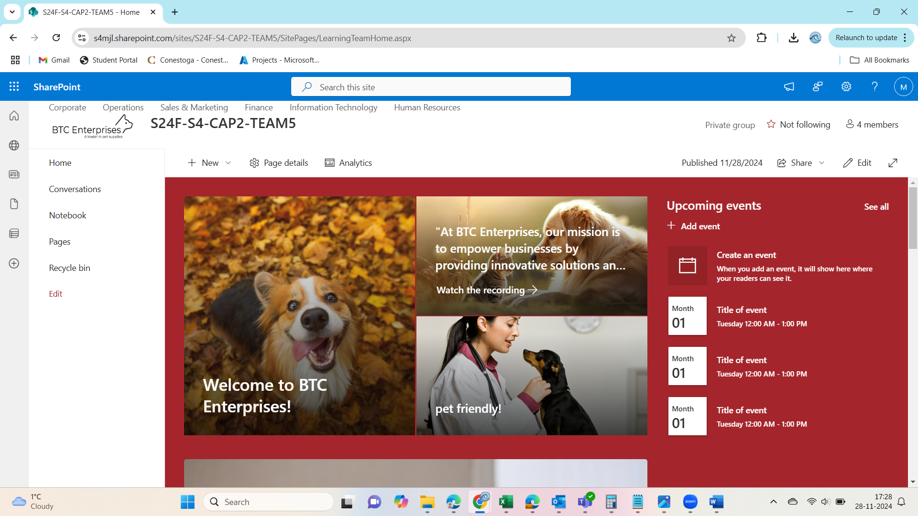

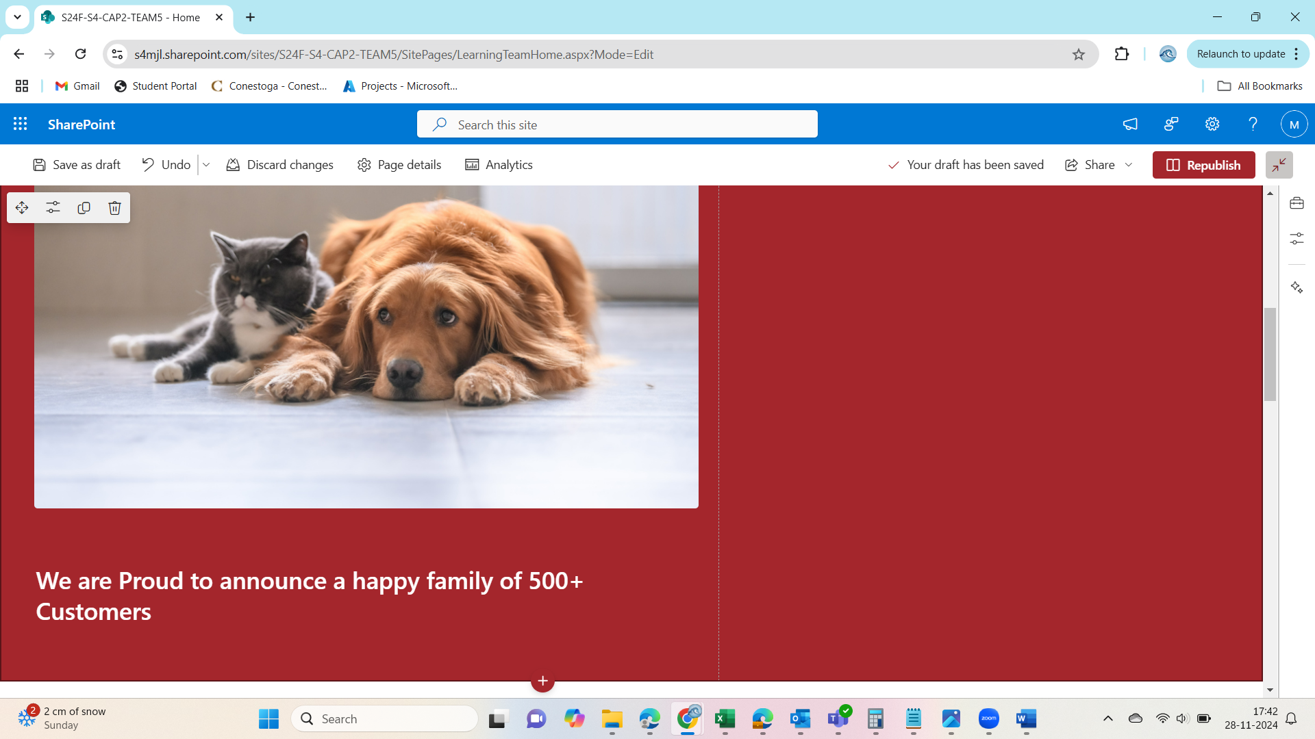

## Department Sub-Site

The SharePoint site we created for the BTS Enterprise has sub-sites like corporate, operations, Sales & Marketing, Finance, Information Technology, and Human Resources.

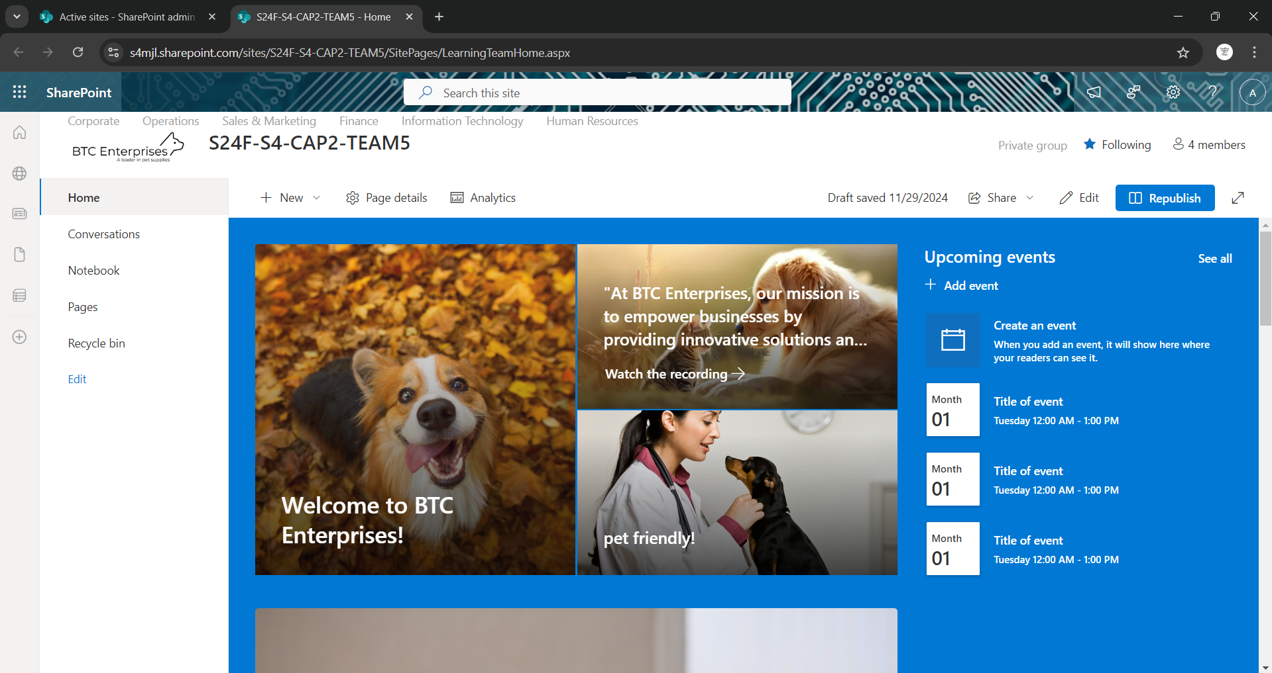

This is the corporate page of the SharePoint site

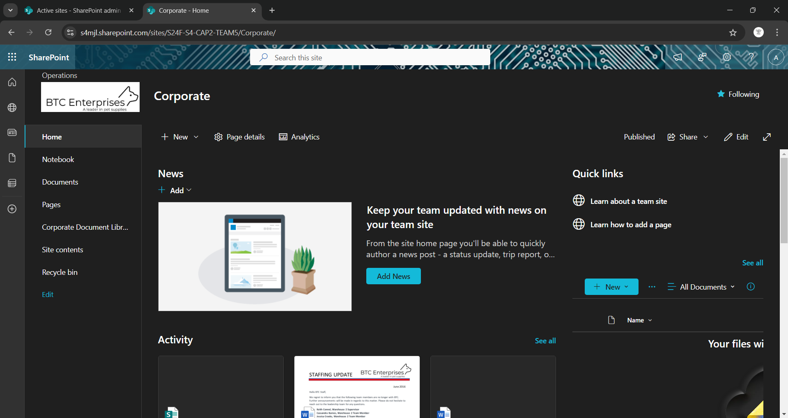

Operations page which has two subsites

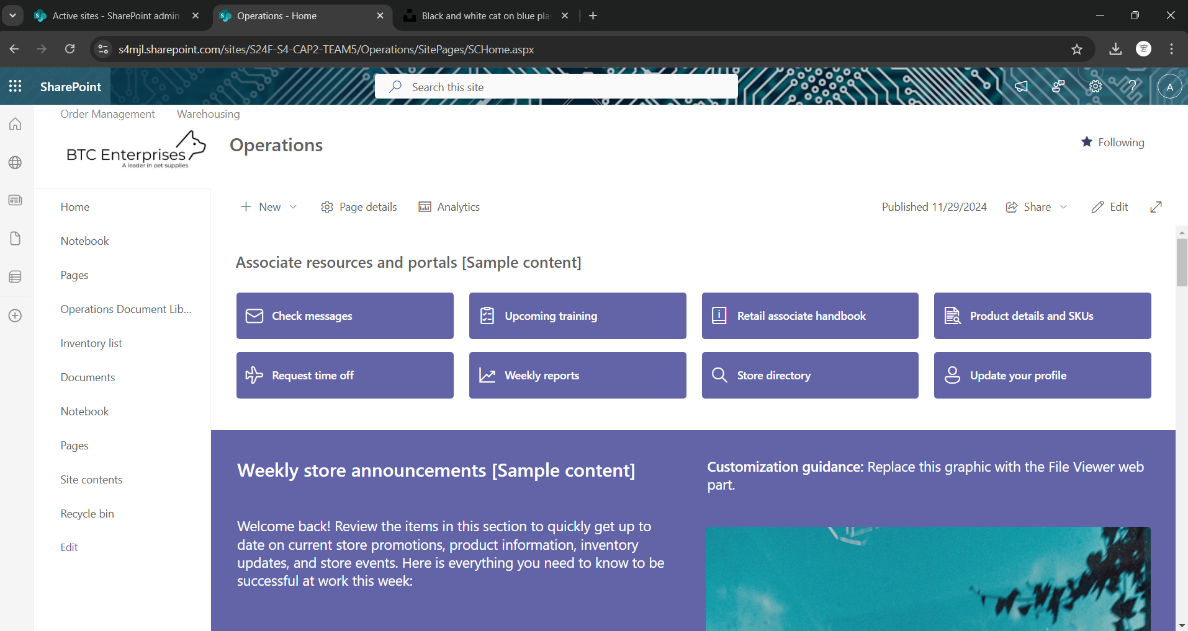

Sales & Marketing page which has 2 subsites and a document library

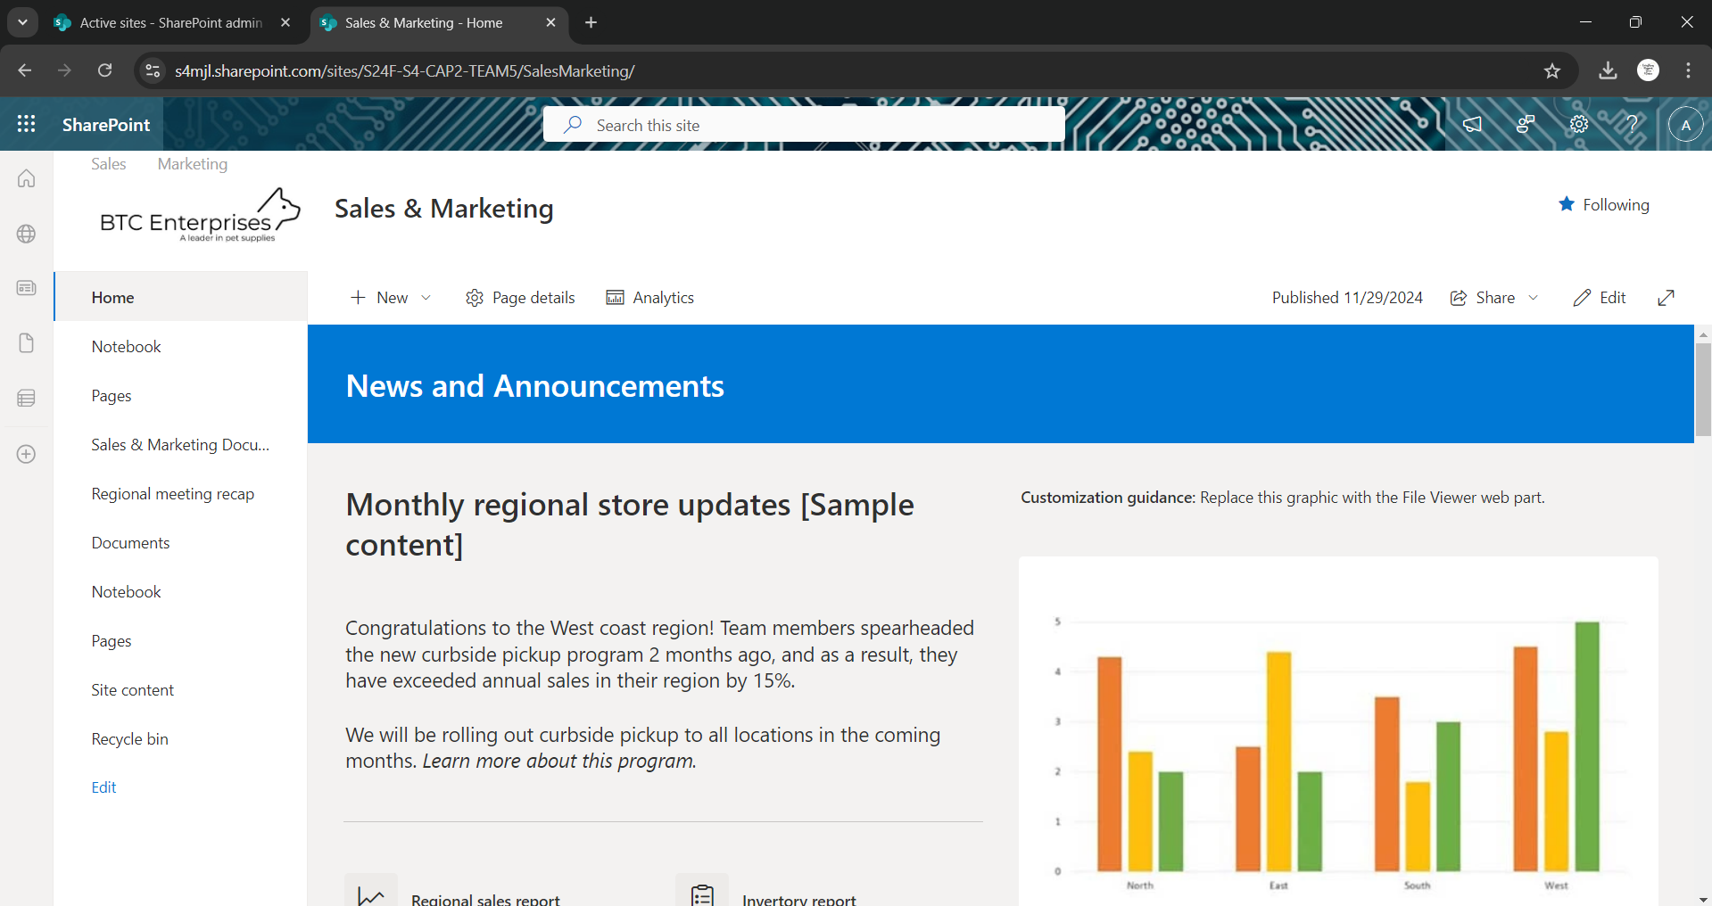

The finance page which has two subsites of its own

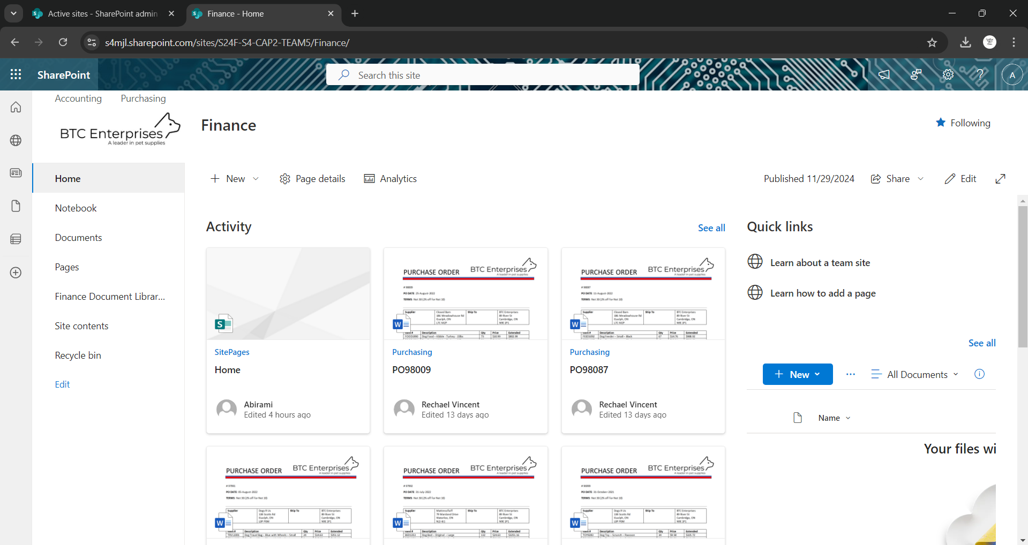

Information Technology page which has two sub-sites that belongs to the IT department.

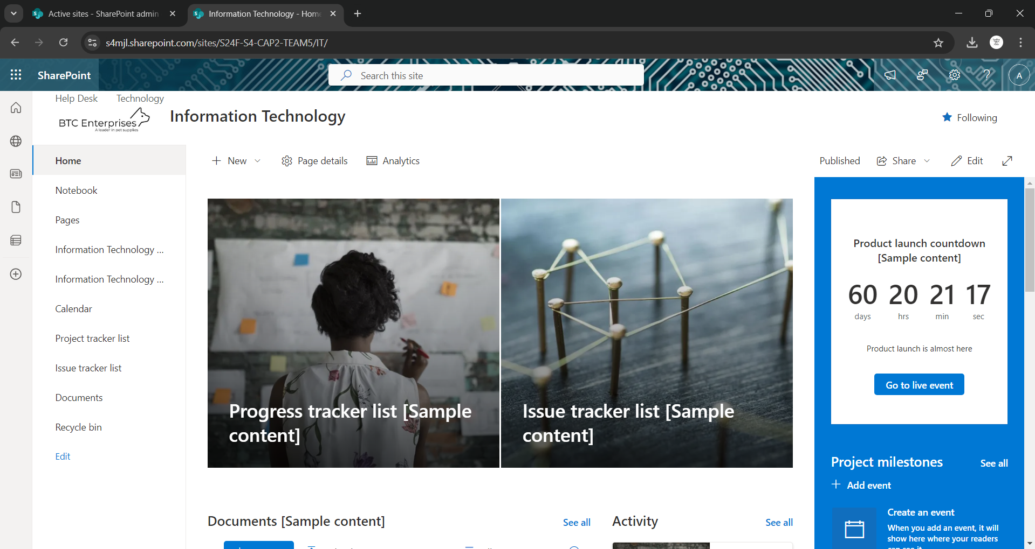

Human Resource page which has three subsites and two document libraries.

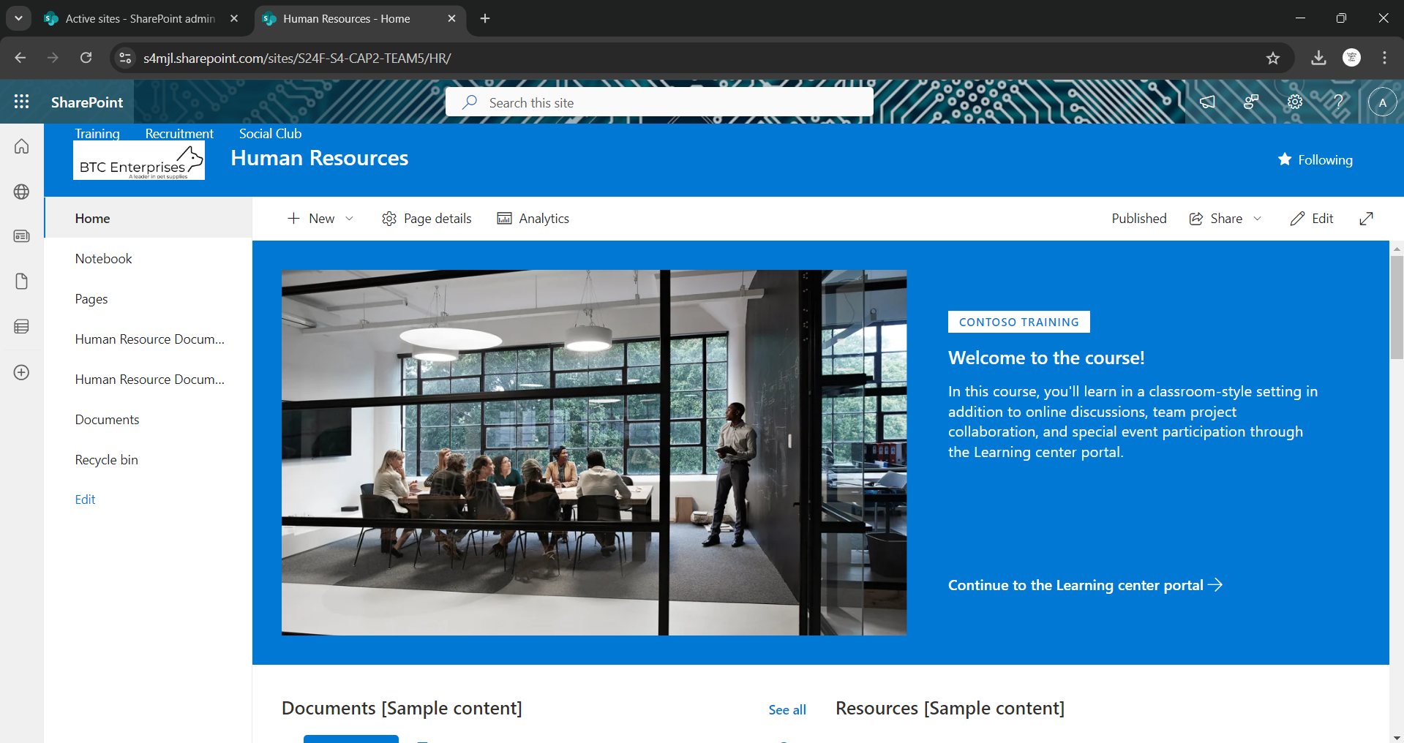

## Sub Department Sub-Site

Operations- Order Management sub-sites of the SharePoint site

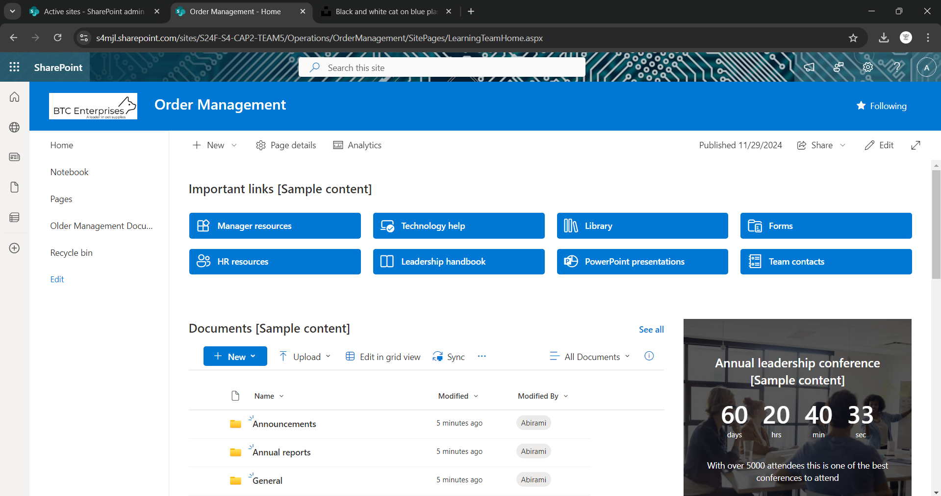

Operations – Warehousing another subsite of the SharePoint site

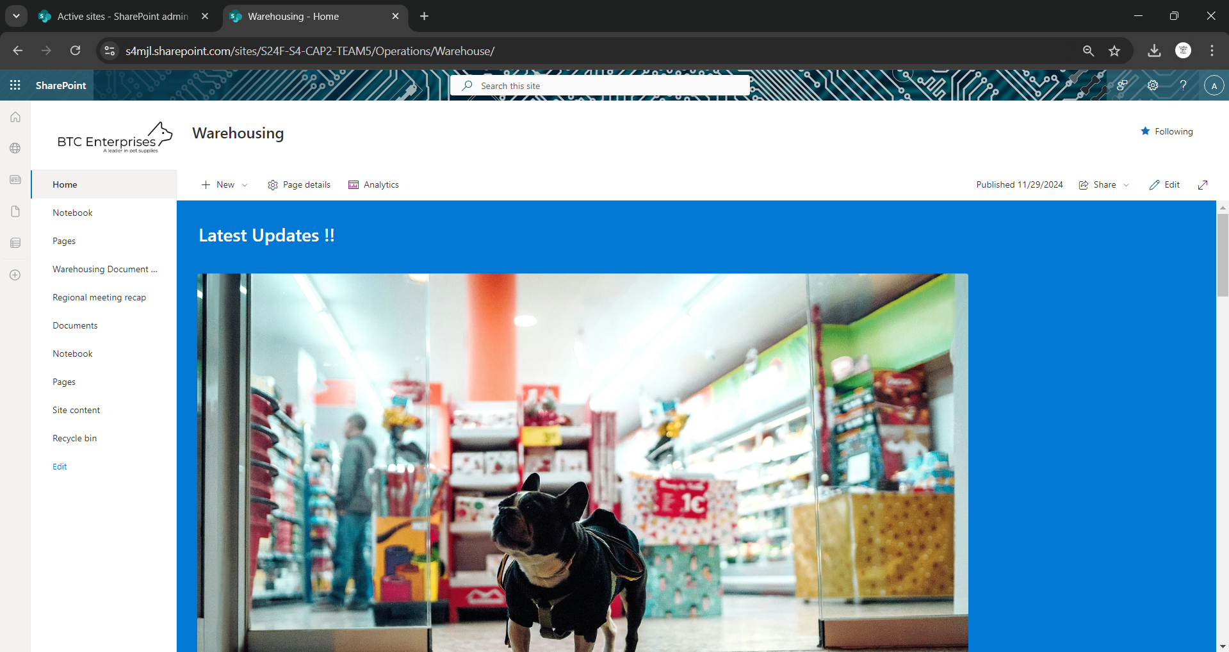

Sales & Marketing – Sales subsites which have two document library

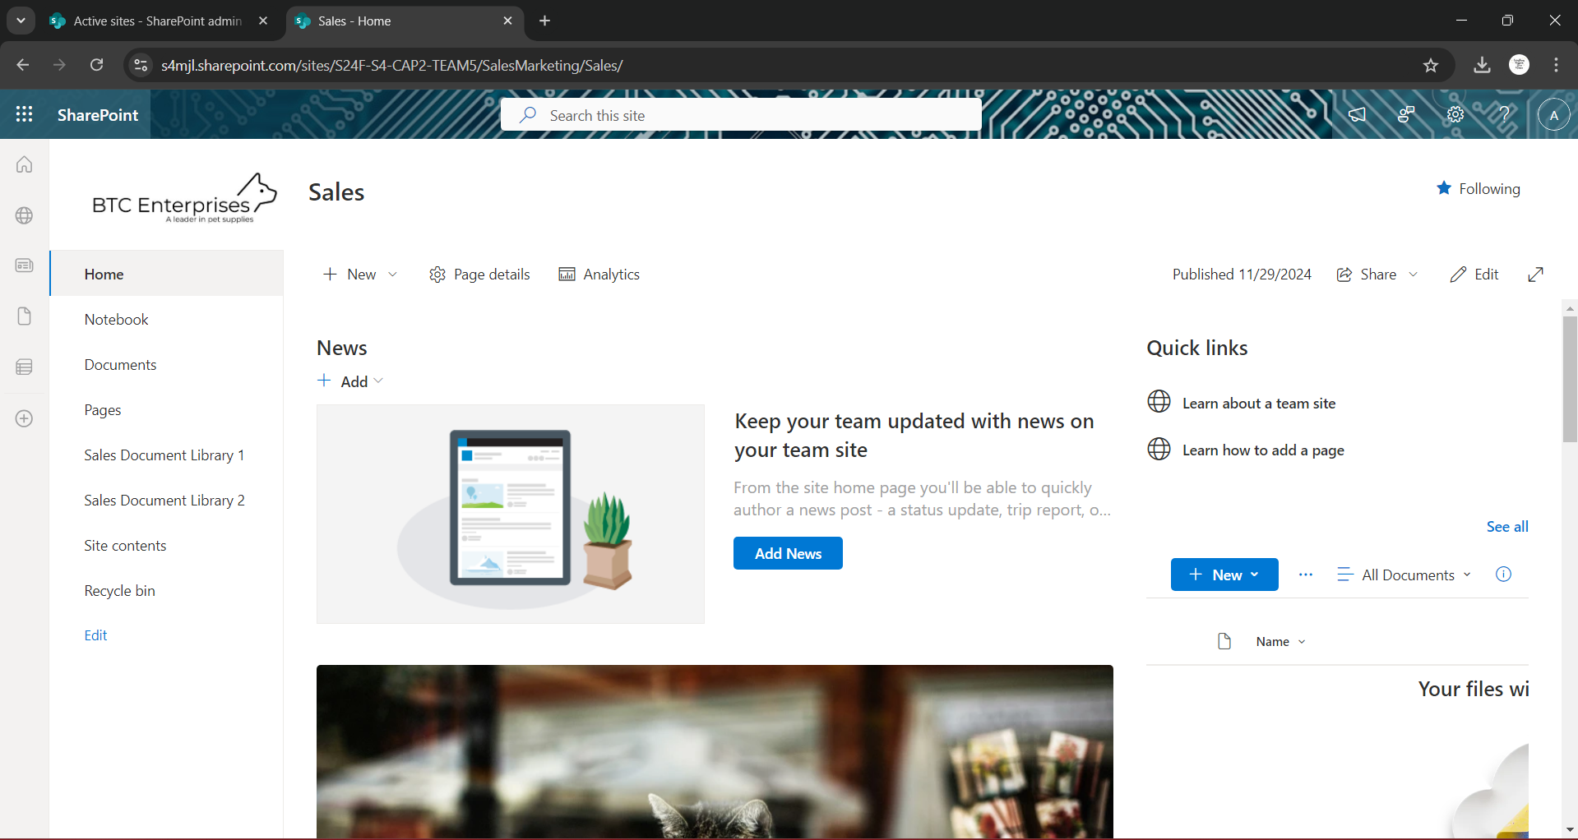

Sales & Marketing – Marketing which is a subsite a document library

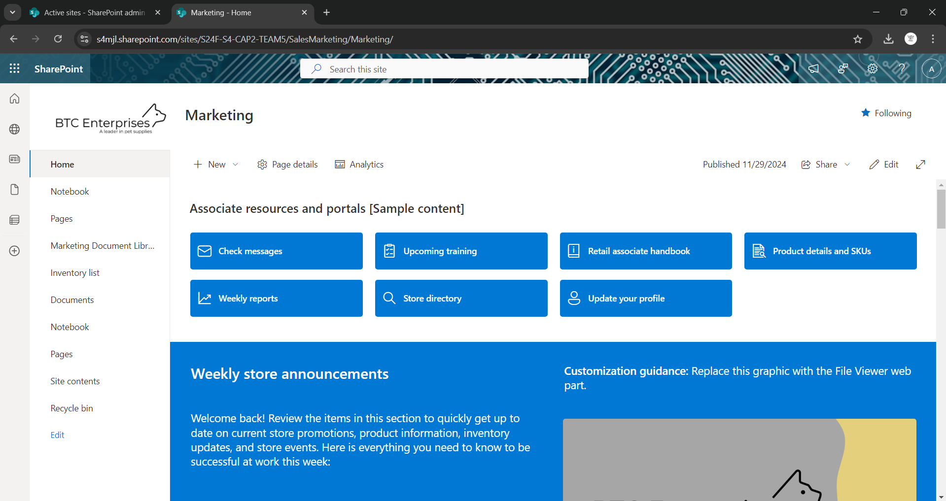

Finance – Accounting which has documents related to the accounting documents.



Finance – Purchasing sub-site which has related documents and files within the finance department

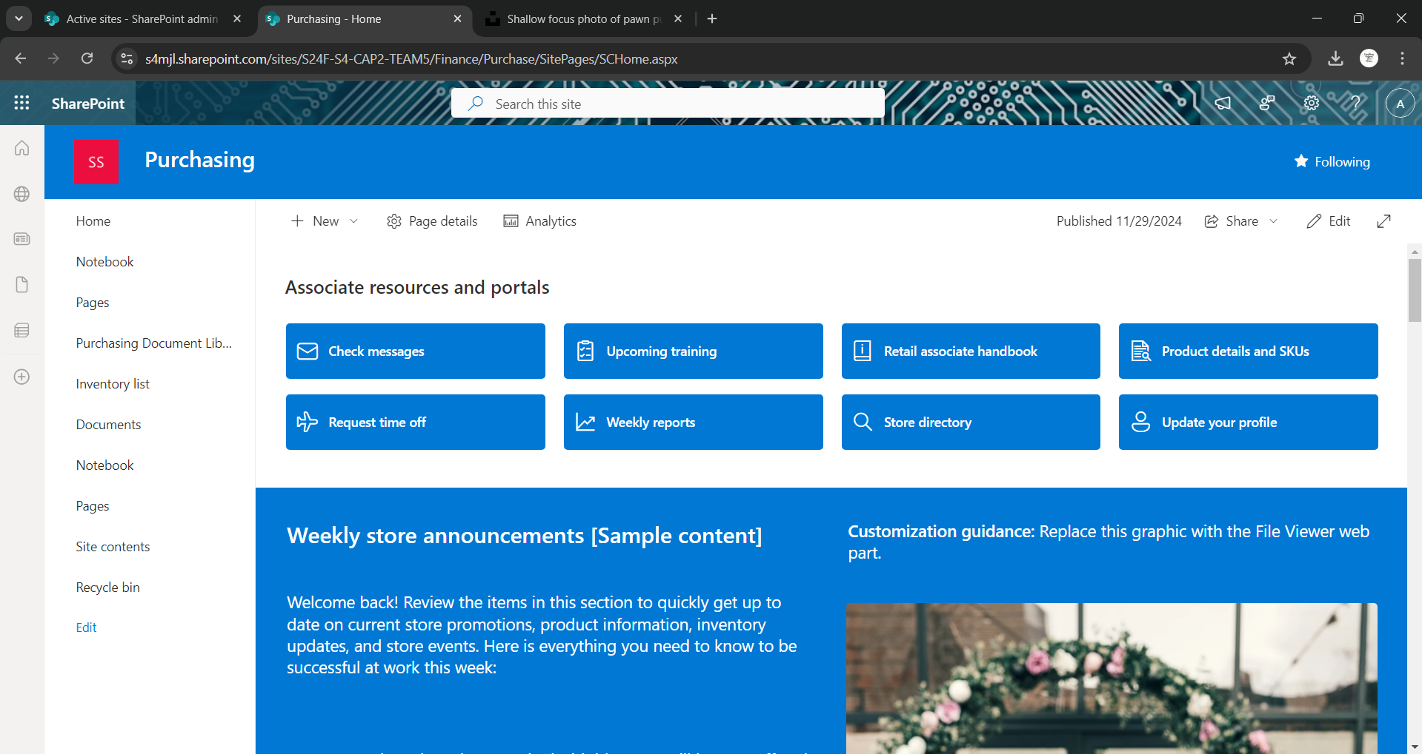

Information Technology – Helpdesk which has information related to the department and can be accessed only by helpdesk team

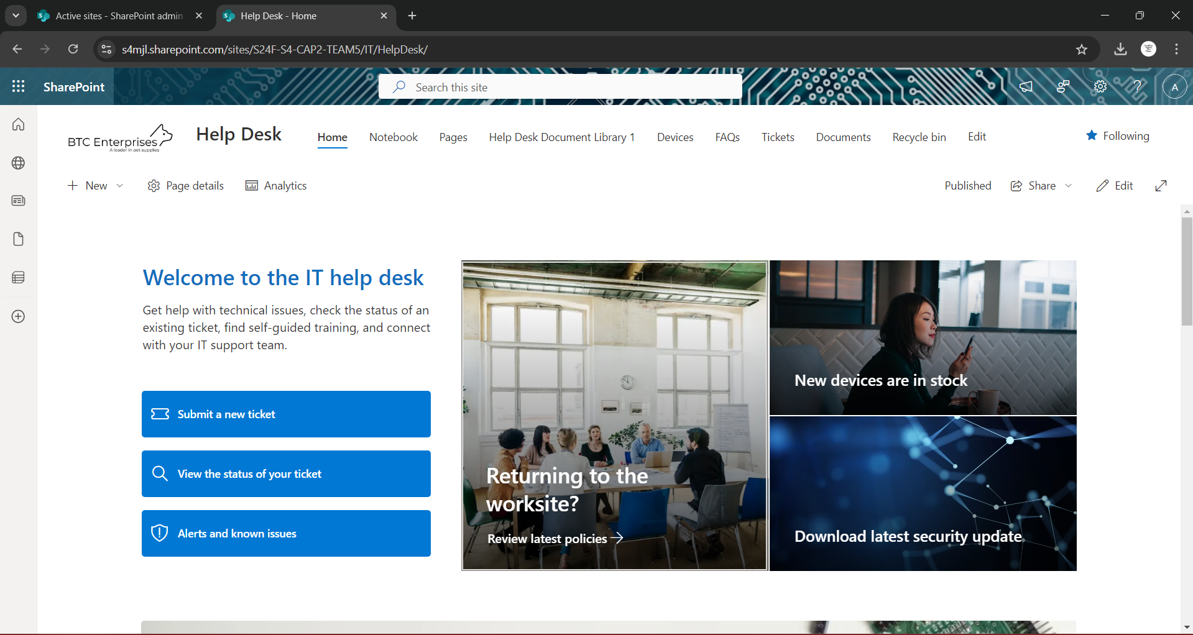

Information Technology – Technology subsite which has documents related to IT, and only members of that department have access to it.

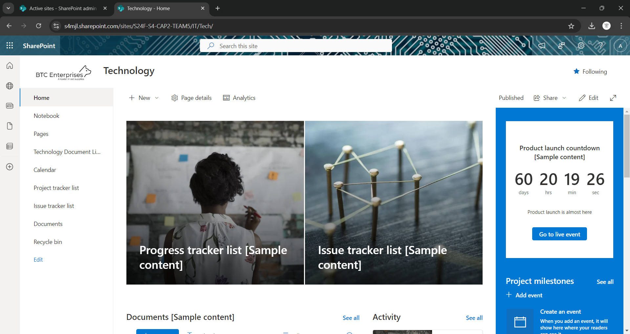

Human Resource – Training, that has documents and details related to the department

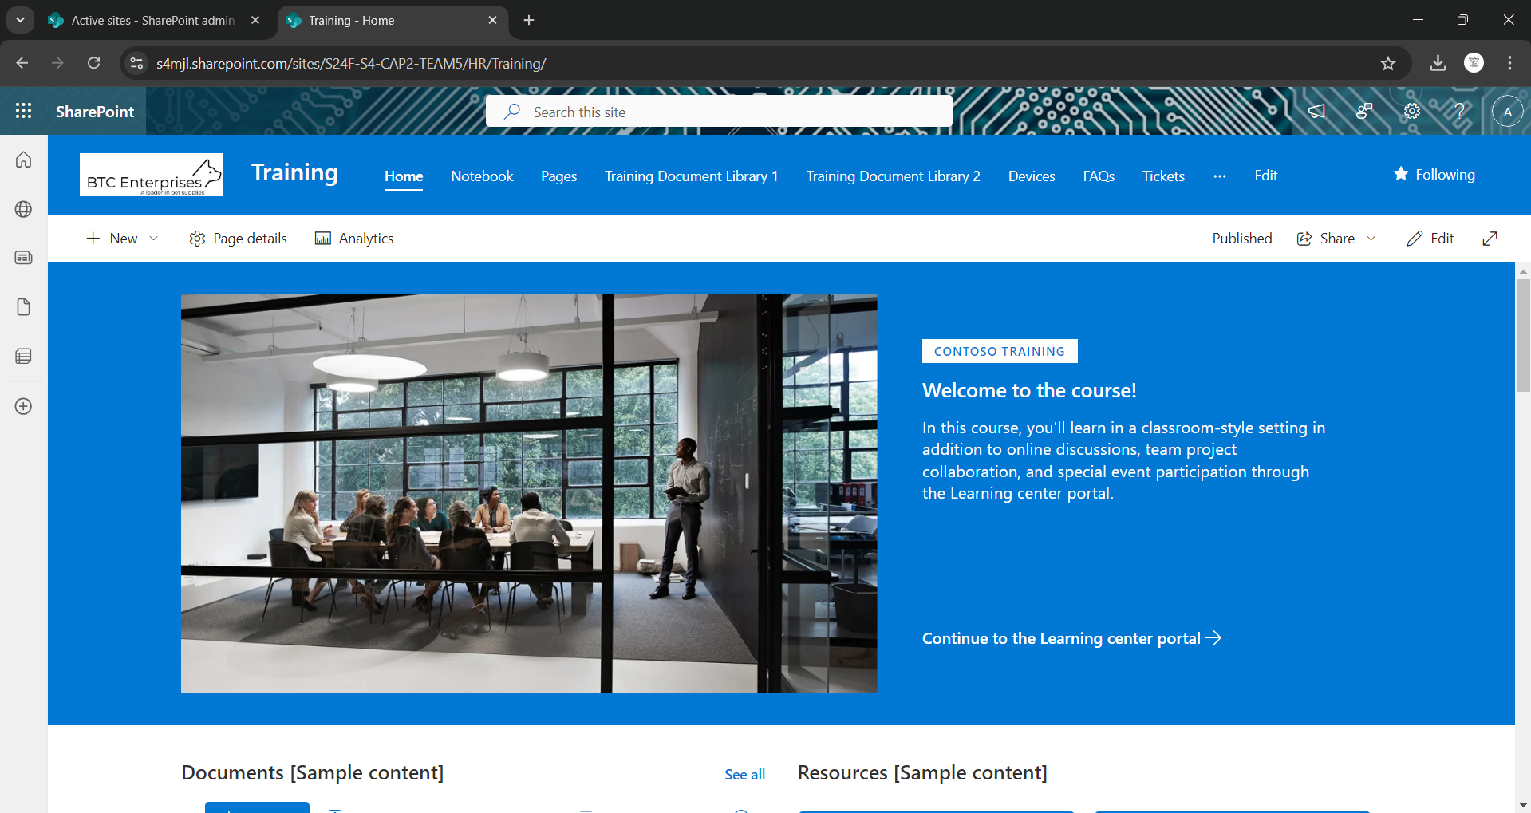

Human Resource – Recruitment, only the team has access to it.

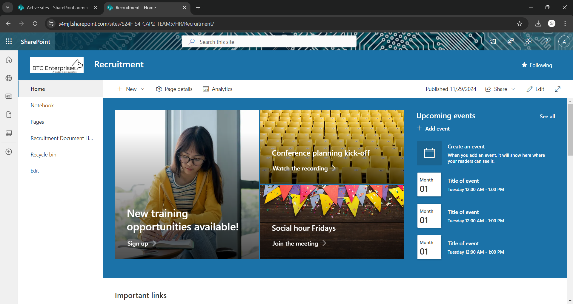

Human Resource – Social Club, which has documents related to it.

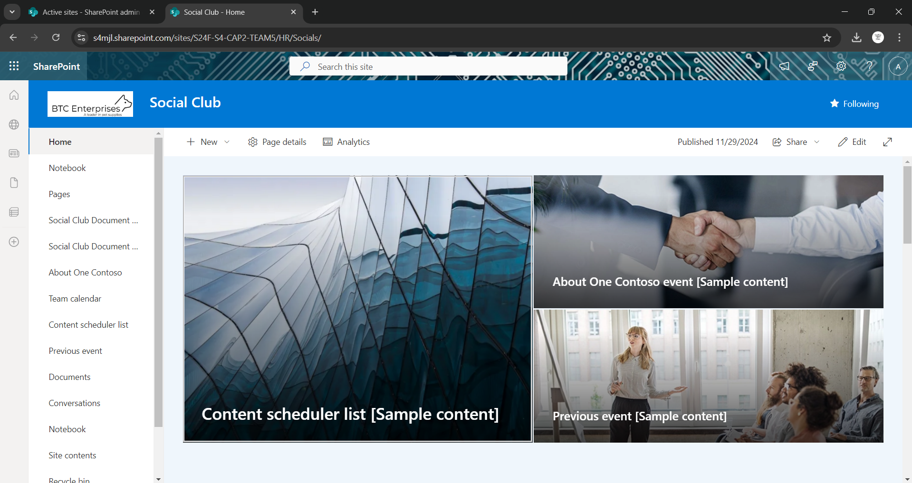

## Department Process

There are three department processes.

**Budget Process:**

The Finance Department's operations depend heavily on the Budget Process. Developing, preserving, and safeguarding access to firm financial data are all included. Only key executives, including the CEO, CTO, CFO, COO, CHRO, and CMO, would have secure access to budget data thanks to the procedure. Making a secure folder with limited access was the solution, guaranteeing that crucial budget information is protected and that only authorized personnel may access it.

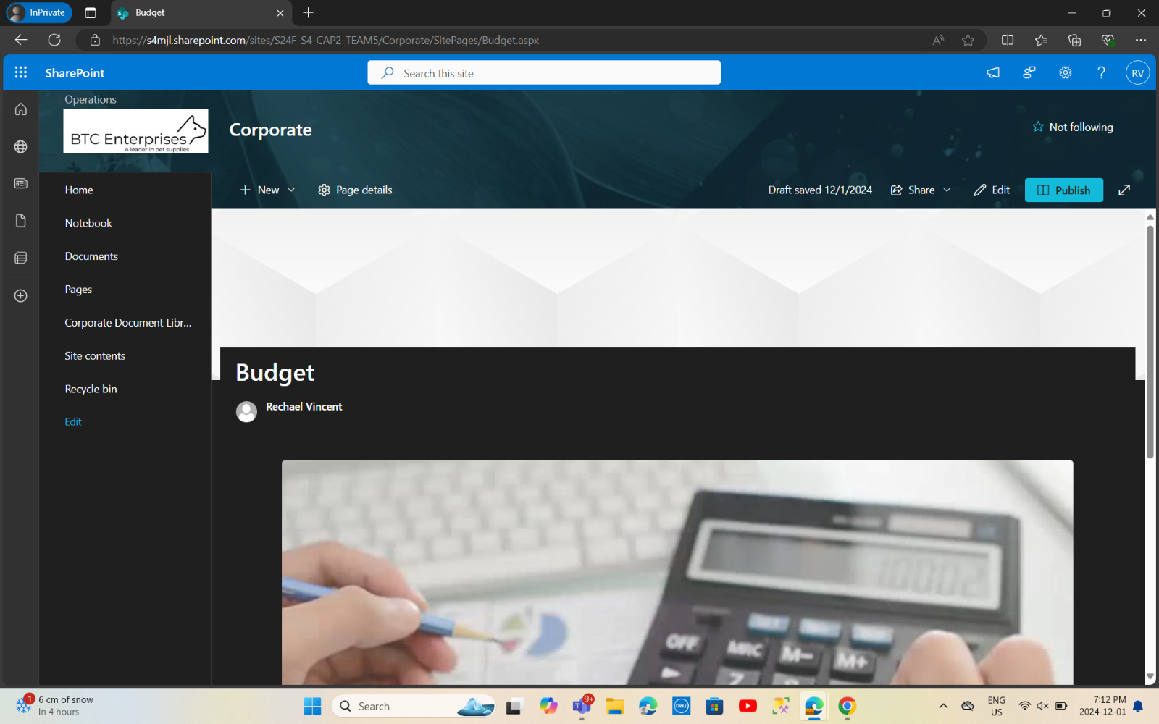

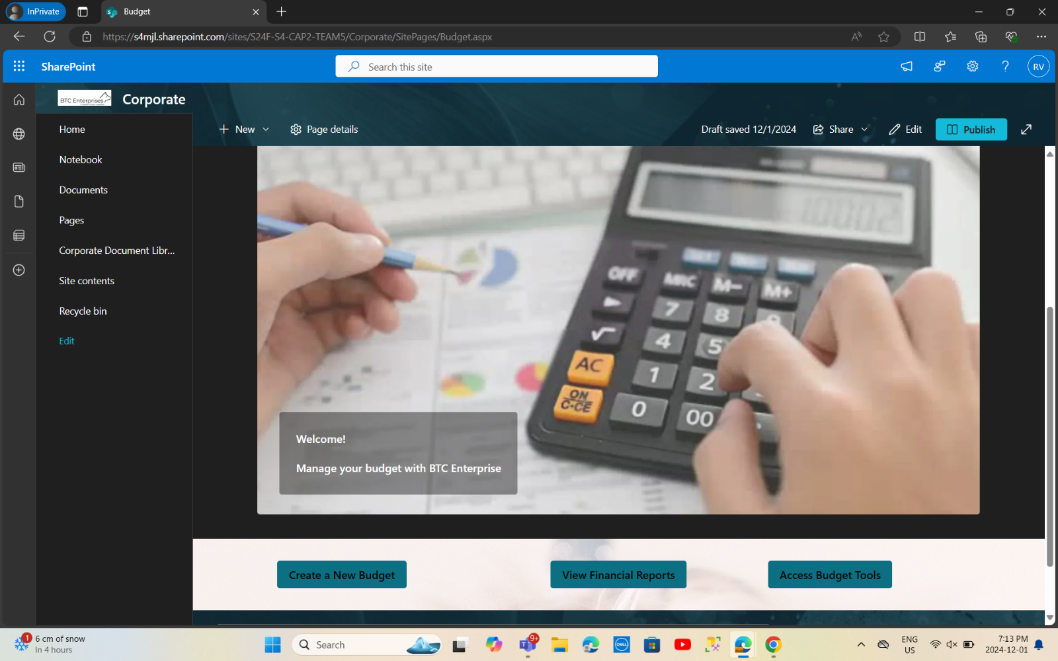

**Expense Report Process:**

The Finance department's expenditure claims are automatically approved and managed through the expense reports process. Forms submitted by staff members and automatically approved by the finance manager are used in this automated process. When processing expenditure reports, this method increases efficiency and accuracy by avoiding manual involvement and expediting the approval process.

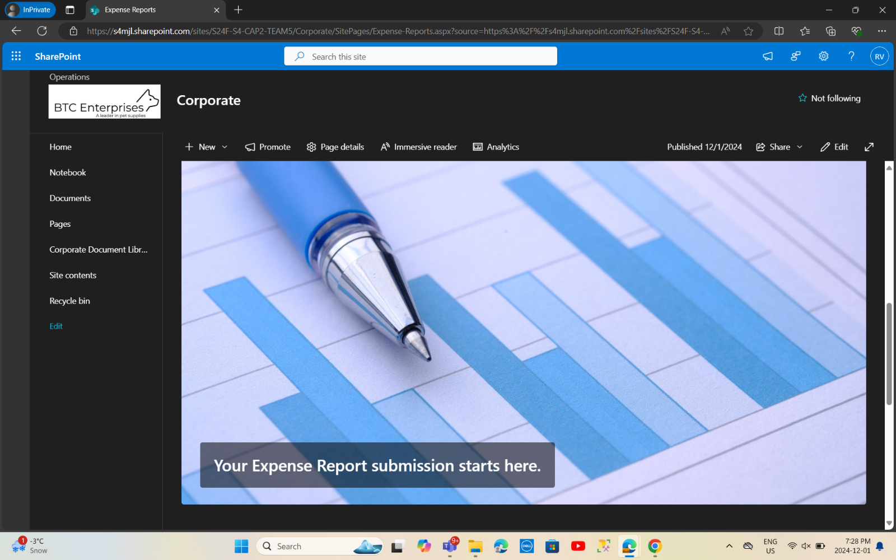



**Account Codes Process:**

Managing and changing account codes, which are necessary to accurately categorize financial transactions, is part of the Account Codes Process. To ensure that someone with the required authority and expertise maintains account codes, the process is limited to the Vice President of Finance. The setup provides a safe space where the VP can maintain and update account codes without fear of unauthorized changes.

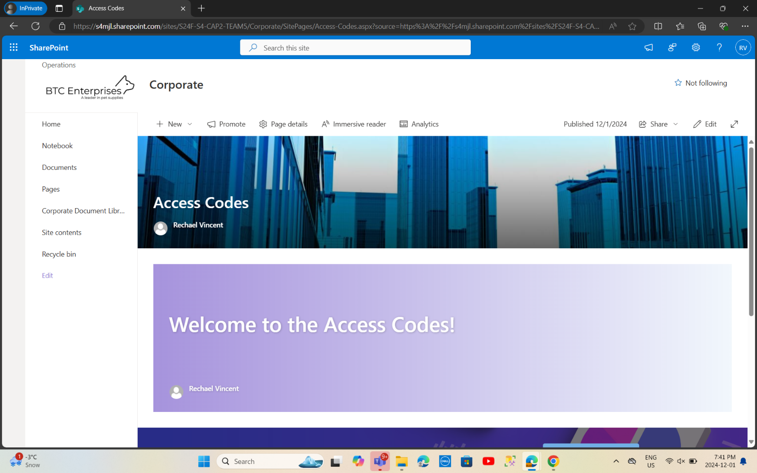

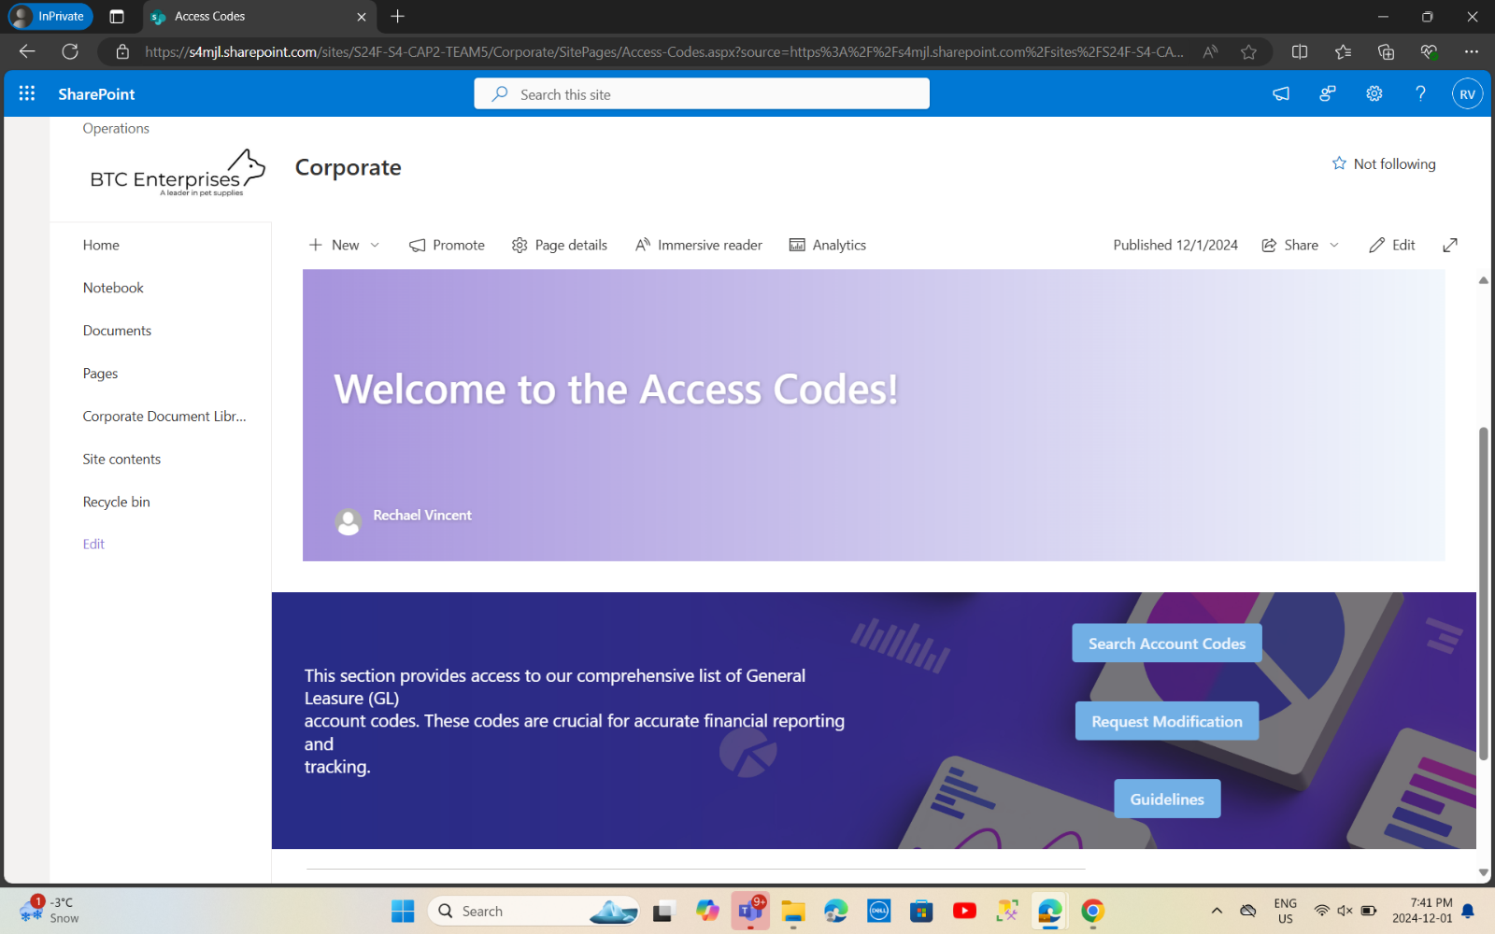

## Reporting

Power BI is a business intelligence tool developed by Microsoft for Data Visualization. It can be used to connect various data sources, transform and model data, and create interactive reports and dashboards for data insights.

**Components of Power BI**

Desktop: A Windows application used for designing and creating reports.

Service: A cloud-based platform for sharing, collaborating, and accessing reports and dashboards.

Mobile: Mobile apps for viewing and interacting with reports and dashboards on the go.

Gateway: A tool to connect on-premises data sources to Power BI Service.

Server Report: An on-premises report server for hosting reports.

**Benefits of Power BI**

Ease of Use: User-friendly interface with drag-and-drop functionality.

Integration: Seamlessly integrates with other Microsoft tools like Excel, Azure, and Teams.

Scalability: Suitable for individuals, small teams, and large organizations.

Automation: Scheduled data refreshes ensure reports and dashboards always display the latest data.

Interactivity: Enables dynamic interaction, filtering, and customization.

## UAT Presentation



**Agenda**

1. **Introduction**
   * Overview of the project.
   * Goals of User Acceptance Testing (UAT).
2. **SharePoint Environment Structure**
   * Main site structure.
   * Department subsites overview.
3. **Testing Scope**
   * Key functionalities to test.
   * User roles and permissions.
4. **UAT Scenarios**
   * Test cases and expected outcomes.
5. **Feedback Collection**
   * Process for reporting issues.
6. **Next Steps**
   * Post-UAT fixes.
   * Go-live plan.

## Introduction

**Purpose of UAT**

User Acceptance Testing ensures the solution meets client requirements, functions as expected, and is user-friendly for all stakeholders.

**Key Goals**

* Validate content migration accuracy.
* Confirm site and subsite structures align with department needs.
* Verify permissions and access levels.
* Test navigation, search functionality, and document management.

## SharePoint Environment Structure

**Main Site**

* Centralized hub for organization-wide content.
* Standardized branding and layout.

**Department Subsites**

1. **Human Resources:** Policies, employee forms, training materials.
2. **Finance:** Budgets, invoices, and financial reports.
3. **Operations:** SOPs, workflows, and operations data.
4. **IT:** Technical documentation and troubleshooting guides.
5. **Marketing:** Campaigns, creative assets, and market research.

**Hierarchy**

* Top-level site as the central hub.
* Subsites with unique content and tailored permissions.

## Testing Scope

**Core Functionalities to Test**

1. **Content Verification**
   * Accuracy of migrated documents.
   * Folder structure integrity.
2. **Permissions and Security**
   * Verify role-based access for each department.
   * Ensure restricted content is inaccessible to unauthorized users.
3. **Navigation**
   * Test links and menu structure for logical flow.
   * Check breadcrumb navigation.
4. **Document Management**
   * Upload, edit, delete, and download documents.
   * Version control functionality.
5. **Search Functionality**
   * Verify search accuracy.
   * Test filters and sorting.
6. **User Interface**
   * Validate consistency in layout, branding, and responsiveness.

## UAT Scenarios

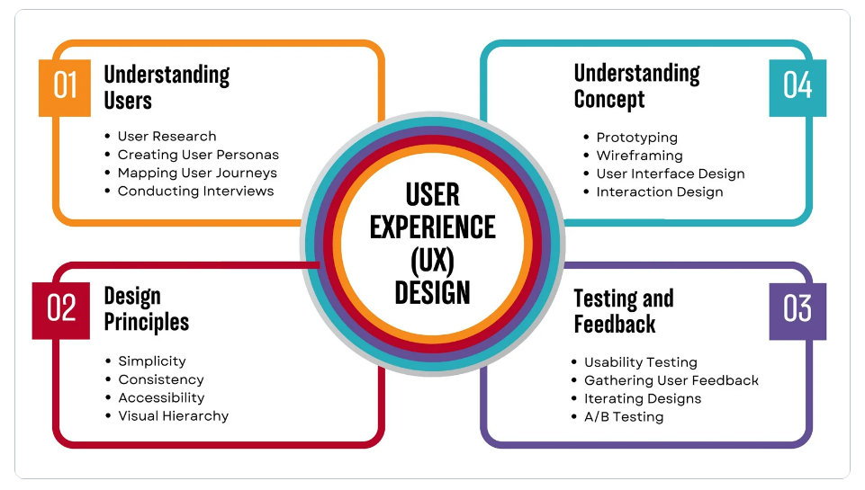

**Scenario 1:**

**Content Accessibility**

* **Test Case:**

Verify that HR team members can access only HR-related documents.

* **Expected Outcome:**

The HR team has access only to their subsite and no other department's content.

**Scenario 2:**

**Document Upload and Versioning**

* **Test Case:**

Upload a document, make edits, and check version history.

* **Expected Outcome:**

Document versions are saved, and changes are traceable.

**Scenario 3:**

**Navigation and Links**

* **Test Case:**

Test navigation between the main site and subsites.

* **Expected Outcome:**

Navigation is seamless, and links are functional.

**Scenario 4:**

**Search Functionality**

* **Test Case:**

Search for a document using keywords.

* **Expected Outcome:**

Relevant results are displayed with proper filters.

**Scenario 5:**

**User Permissions**

* **Test Case:**

Attempt to access restricted content with unauthorized user credentials.

* **Expected Outcome:**

Access is denied, and the user receives a notification.

## Feedback Collection

**Feedback Process**

1. **Feedback Form:**

Provide a standardized form for reporting issues.

1. **Live Testing Sessions:**

Collect observations during UAT sessions.

1. **Issue Tracker:**

Use a tool (e.g., Jira or Excel) to log and prioritize feedback.

**Key Areas for Feedback**

* Functionality gaps.
* Usability concerns.
* Missing or incorrect content.

## Next Steps

**Review and Fix Issues**

* Resolve all critical and major issues reported during UAT.

**Final Review**

* Conduct a final round of testing to ensure all fixes are in place.

**Go-Live Preparation**

* Migrate any remaining content.
* Train users on the finalized SharePoint environment.

**Go-Live**

* Launch the SharePoint sites and subsites.
* Monitor for any post-launch issues.

## Conclusion

Thank you for your participation and valuable feedback! Your insights play a crucial role in the success of this project. By working together, we are not only ensuring that the SharePoint environment aligns with organizational needs but also fostering an efficient, collaborative space that enhances productivity. This project is a significant step towards optimizing workflows and improving accessibility for all users.

Your contributions will help shape a SharePoint environment that is user-friendly, streamlined, and better equipped to support the organization's objectives. As we move forward, continuous feedback will be essential in refining and adapting our solutions to meet evolving needs.

We appreciate your dedication and commitment to this initiative, and we look forward to achieving great results together.

Thank you again, and let's continue making this project a success!

## Gantt Chart

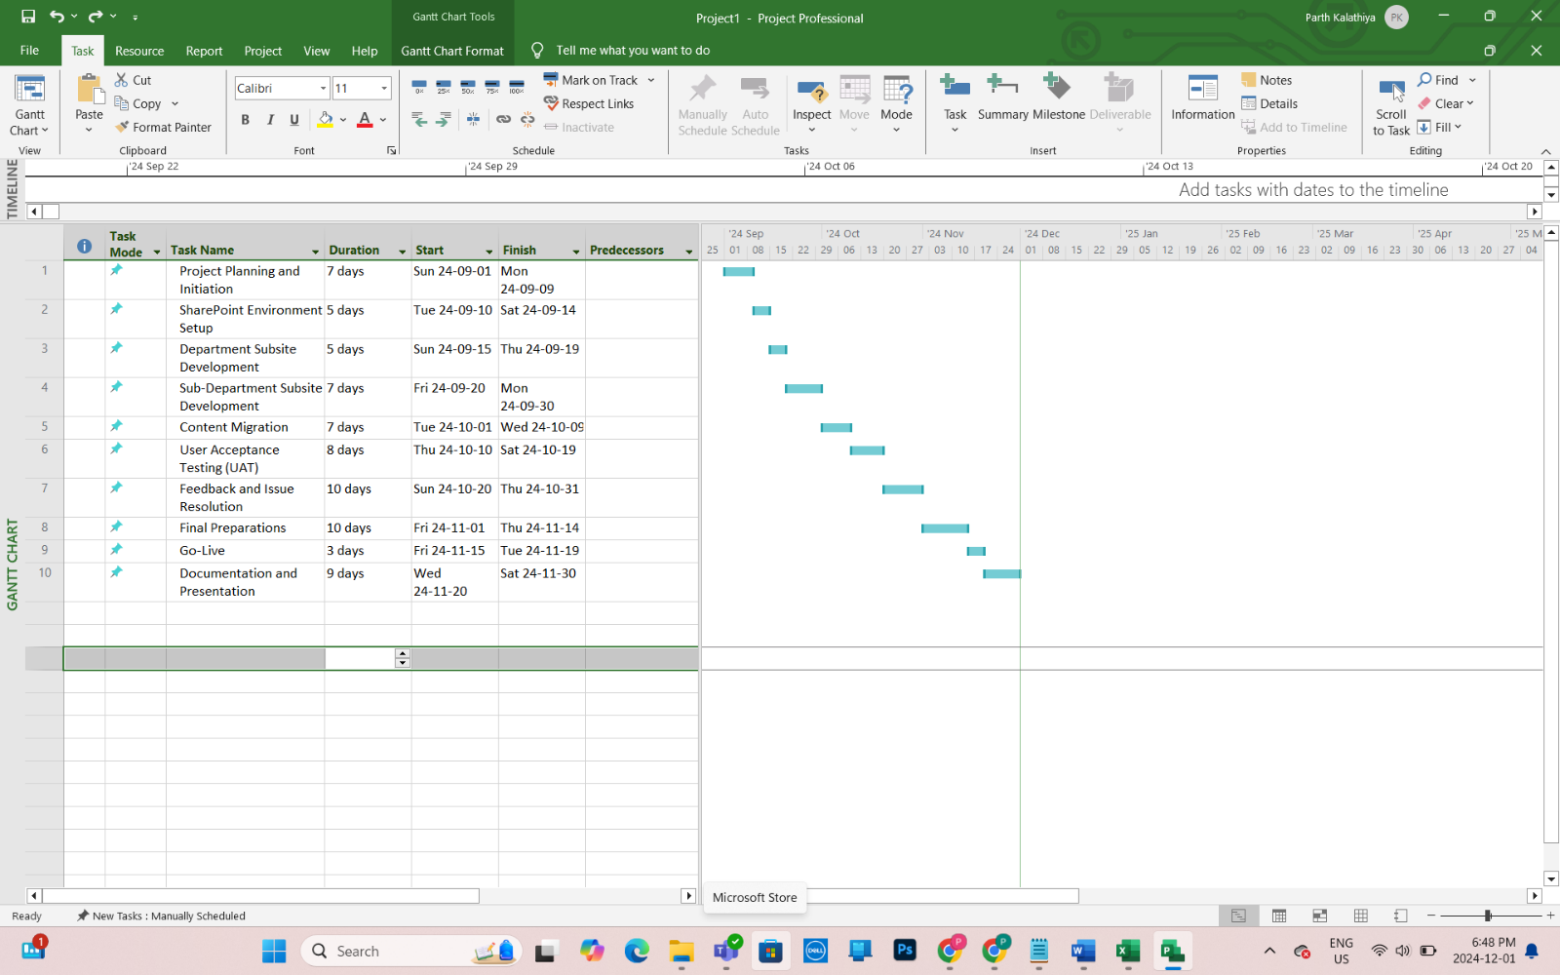This screenshot shows Gantt chart of our entire projects process.

# Team Contributions

|  |  |
| --- | --- |
| Team Member | Contribution |
| Abirami Mohanasundaram | Document creation  Department sub-site  Sub-department sub-site |
| Mounika Boju | Corporate home page  UAT Presentation |
| Parth Babubhai Kalathiya | Gantt Chart  Academic Abstract |
| Rechael Vincent Lopes | Department Process |

# References

NA

# Appendix

HR

Human Ressources

IT

Information Technologies

FAQ

Frequently Asked Questions

MS - Microsoft

FIN - Finance